4.2.7 Packet Tracer – Configure Router-on-a-Stick Inter-VLAN Routing (Instructor Version)
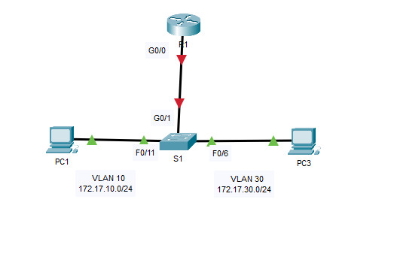
Addressing Table
Device | Interface | IPv4 Address | Subnet Mask | Default Gateway
R1 | G0/0.10 | 172.17.10.1 | 255.255.255.0 | N/A
 | G0/0.30 | 172.17.30.1 | 255.255.255.0
PC1 | NIC | 172.17.10.10 | 255.255.255.0 | 172.17.10.1
PC2 | NIC | 172.17.30.10 | 255.255.255.0 | 172.17.30.1
Objectives
- Part 1: Add VLANs to a Switch
- Part 2: Configure Subinterfaces
- Part 3: Test Connectivity with Inter-VLAN Routing
Scenario
In this activity, you will configure VLANs and inter-VLAN routing. You will then enable trunk interfaces and verify connectivity between VLANs.
Instructions
Part 1: Add VLANs to a Switch
Step 1: Create VLANs on S1.
Create VLAN 10 and VLAN 30 on S1.
S1(config)#vlan 10
S1(config-vlan)#vlan 30
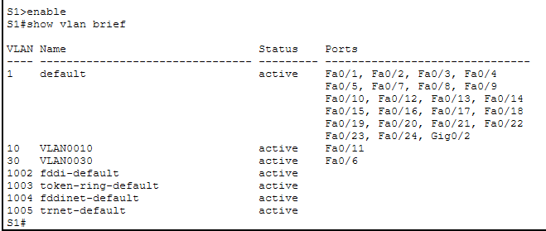
Step 2: Assign VLANs to ports.
a. Configure interfaces F0/6 and F0/11 as access ports and assign VLANs.
- Assign the port connected to PC1 to VLAN 10.
- Assign the port connected to PC3 to VLAN 30.
S1(config)#interface f0/11
S1(config-if)#switchport mode access
S1(config-if)#switchport access vlan 10
S1(config-if)#interface f0/6
S1(config-if)#switchport mod access
S1(config-if)#switchport access vlan 30
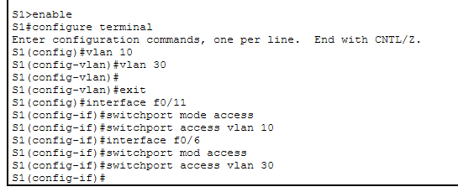
b. Issue the show vlan brief command to verify VLAN configuration.
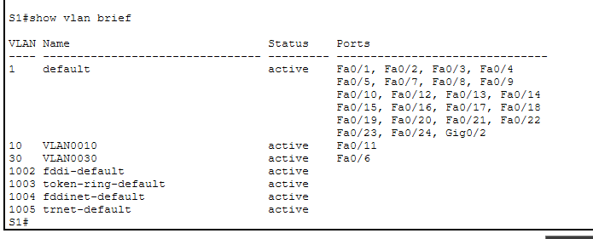
S1# show vlan brief

Step 3: Test connectivity between PC1 and PC3.
From PC1, ping PC3.
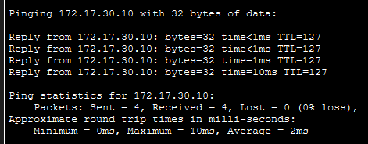
Were the pings successful? Why did you get this result?
The pings were successful, and there are zero latency issues.

Part 2: Configure Subinterfaces
Step 1: Configure subinterfaces on R1 using the 802.1Q encapsulation.
a. Create the subinterface G0/0.10.
- Set the encapsulation type to 802.1Q and assign VLAN 10 to the subinterface.
- Refer to the Address Table and assign the correct IP address to the subinterface.
R1(config)# int g0/0.10
R1(config-subif)# encapsulation dot1Q 10
R1(config-subif)# ip address 172.17.10.1 255.255.255.0
b. Repeat for the G0/0.30 subinterface.
R1(config-subif)#int g0/0.30
R1(config-subif)#encapsulation dot1Q 30
R1(config-subif)#ip address 172.17.30.1 255.255.255.0
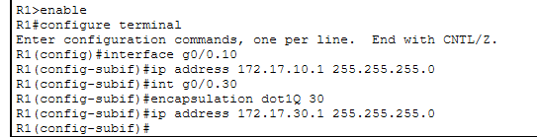

Step 2: Verify Configuration.
a. Use the show ip interface brief command to verify subinterface configuration. Both subinterfaces are down. Subinterfaces are virtual interfaces that are associated with a physical interface. Therefore, in order to enable subinterfaces, you must enable the physical interface that they are associated with.
R1(config)#interface g0/0
R1(config-if)#no shutdown
b. Enable the G0/0 interface. Verify that the subinterfaces are now active.
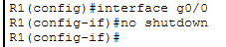
Part 3: Test Connectivity with Inter-VLAN Routing
Step 1: Ping between PC1 and PC3.
From PC1, ping PC3. The pings should still fail. Explain.
Pings fail because the switch port to router is not trunked.
The switch is not yet configured with a trunk port that is connected to the router.
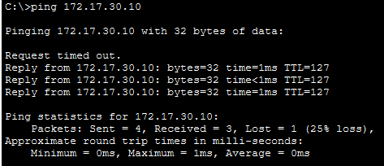
Step 2: Enable trunking.
a. On S1, issue the show vlan command.
What VLAN is G0/1 assigned to?
VLAN 1 (default) before trunking.
b. Because the router was configured with multiple subinterfaces assigned to different VLANs, the switch port connecting to the router must be configured as a trunk. Enable trunking on interface G0/1.
S1(config)#int g0/1
S1(config-if)#switchport mode trunk
How can you determine that the interface is a trunk port using the show vlan command?
You can see that G0/1 is a trunk port since it doesn't show up under any VLAN in the show vlan brief output. Instead, you can check if it's trunking by using show interfaces trunk.
c. Issue the show interface trunk command to verify that the interface is configured as a trunk.
S1#show int trunk
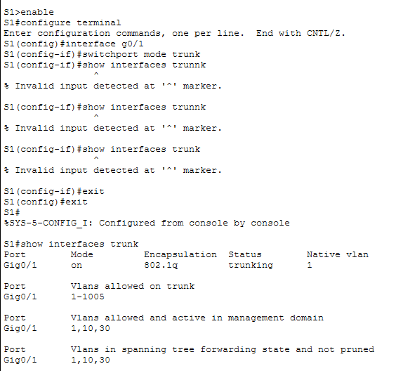
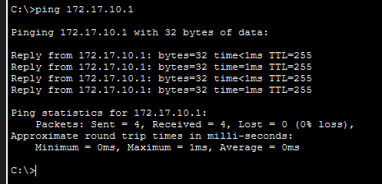
Step 3: Test Connectivity

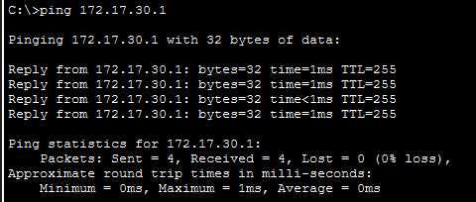
If the configurations are correct, PC1 and PC3 should be able to ping their default gateways and each other.
What addresses do PC1 and PC3 use as their default gateway addresses?
PC1 uses 172.17.10.1 as its default gateway.
PC3 uses 172.17.30.1 as its default gateway.

